**SPH 3U0 EXAM REVIEW PACKAGE**

**Study Tips:**

* Review your notes for each unit
* Make study notes for each unit
* Do homework questions and worksheets again
* Figure out anything you don’t understand and **ask** your teacher
* Redo your tests and quizzes!!! (Questions on the exam are similar to those you have seen on your tests and quizzes.)

**Example Formulae Sheet**

a = Δ Δd=½ (v1+v2) Δt Δd=v2 Δt – ½ a (Δt)2 Δd=v1 Δt + ½ a (Δt)2

Δd= v = ΔΔ FG= Ff= μFN Fnet= ma Fg=mg



% Eff =

v = fλ f = Δ T = Δ f = v = 331.6 + 0.606 T,

fb= ⏐f1-f2⏐ Δdnode = λ f2 = f1 (±) L = λ, λ,λ… L = λ, λ ,λ…

I=Q/Δt ΔE=QV ΔE=VIΔt V= IR

***In Series Circuits:   ***

***In Parallel Circuits:   ***



USEFUL CONSTANTS:

acceleration due to gravity on earth: g = 9.81 m/s2

speed of sound in air at 0C = 331.6 m/s

specific heat capacity of water c= 4.18 x 10 3 J/ kg °C

Universal Gravitational Constant, G= 6.67 x 10 –11 Nm2/kg2

Stuff that we learned this year!

Unit 1

• scalar and vector quantities

• know the difference between position, distance, displacement, speed, velocity, acceleration

• sketch position-time, velocity-time & acceleration-time graphs for uniform and non-uniform

motion

• what information can be gathered from position-time, velocity-time & acceleration-time?

• Famous Five Equations

• Gravity, acceleration due to gravity and projectile motion

Unit 2

• what is a force?

• describe Newton’s three laws of motion

• sketch a free-body diagram

• what is friction and how is it calculated

• distinguish between mass and weight

• what factors affect weight?

• determine the acceleration due to gravity on other planets

• determine the Force of gravity acting between two objects.

Unit 3

• what is the S.I. unit for energy?

• define: work, energy, kinetic energy, gravitational potential energy, power

• what equations are associated with work and energy?

• what is the law of conservation of energy?

• what is efficiency and how is it calculated?

• use energy conservation (conversion between kinetic and potential energies ex roller coaster) to

determine height or speed

• thermal energy and heat transfer

Unit 4

• what kind of wave is sound?

• characteristics of waves

• standing waves and resonance

• describe, sketch and label transverse, longitudinal & standing waves

• what are nodes and antinodes?

• how is the speed of sound calculated?

• use the speed of sound to determine air temperature or vice a versa

• what is intensity and how is it measured?

• Doppler effect

• resonance and Resonant lengths in air columns

Unit 5

• what is electric current, voltage and resistance and Ohm’s Law

• What is the law of electric charges

• sketch simple electric circuits with resistors in series and parallel

• what are Kirchoff’s rules for series and parallel resistors?

• what is a magnet and what are magnetic materials

• what is the law of electromagnetism?

• state and apply the three right-hand rules

• How does a motor work?

• what is electromagnetic induction?

• state Lenz’s law and how it applies

SPH3U0 Questions to Get You Started on your Exam Review….

**Kinematics**

1. A car travelling at an initial velocity of 60.0 km/h east accelerates at 0.250 m/s2 west for 20.0 seconds.

a) Find its final velocity.

b) How far did the car travel while it accelerated? *ANS: a) 42.0 km/h b) 283 m*

2. A student walks 45 m [West], then 75 m [North] and finally 22 m [East] to reach the school gym.

The entire walk lasted 3.6 minutes. Find:

a) The student's resultant displacement.

b) The student's average velocity.

c) The student's average speed. *ANS: a) 78 m [17°W of N], b) 0.36 m/s [17°W of N] c) 0.66 m/s*

3. A bartender slides a cold pop down the bar counter towards a customer who just misses catching the can.

The can slides off the counter with an initial velocity of 4.5 m/s horizontally. If the counter is 1.2 m high find:

a) the time it takes the can to land on the floor

b) the horizontal distance the can travels before landing on the floor

c) the final velocity of the can as it strikes the floor.

*ANS: a) 0.49s, b) 2.2 m c) 6.6 m/s [47° below the horizontal]*

**Dynamics**

3. State Newton's Three Laws of Motion.

4. A sled (mass 15.8 kg) is being pulled along horizontal ground with an applied force of 47.0 N [east]. There is a

frictional force of 17.8 N [West] opposing the motion. Find the sled's acceleration. *Ans: 1.8 m/s2 [East]*

5. A crate with mass 50.0 kg is pushed with an applied force of 175 N at a constant velocity of

2.5 m/s on a rough floor.

a) Draw a free body diagram of the crate.

b) Find the coefficient of kinetic friction.

c) How would the coefficient of static friction compare with your answer to (b)? *ANS: b) 0.357*

6. An astronaut in her space suit has a weight of 1.225 x 10 3 N on Earth. Her weight on the Mars is 4.50 x 10 2 N.

Find the acceleration due to gravity on Mars. *ANS: 3.60 N/kg*

7. Find the magnitude of the force of gravitational attraction between a 55.0 kg student and a 75.0 kg student who

are sitting 2.25 m apart. *ANS: 5.43 x 10-8 N*

**Energy**

8. A ball with mass 500.0 g is thrown up with an initial speed of 7.00 m/s from a cliff top 10.0 m above a river below.

Assuming air resistance can be ignored,

a) find the ball's initial gravitational potential energy, its initial kinetic energy and its initial total mechanical energy.

b) find the maximum height of the ball above the river.

c) find the final speed of the ball just before it lands in the river.

*ANS: a) 49 J, 12 J, 61 J b) 12 m c) 16 m/s*

**Electricity and Magnetism**

9.A toaster (resistance 18.0), a blender (resistance 48.0 Ω) and a coffee maker (resistance 16.0 Ω ) are connected in

parallel with a 120 V wall outlet.

1. Draw a diagram illustrating the circuit.
2. Calculate the equivalent resistance of the three appliances and find the total current in the circuit.
3. Calculate the current and power electrical power dissipated by each appliance.

*ANS: a) 7.20 Ω b) 17 A c) Toaster-6.7 A, 8.0 x 10 2 W Blender-2.5 A, 3.0 x 10 2 W ,*

*Coffee Maker-7.5 A, 9.0 x 10 2W*

10. a) Discuss the basic principle of electromagnetism discovered by Oersted.

b) Draw the magnetic field associated with each conductor below, assuming positive conventional current is flowing in the direction indicated.

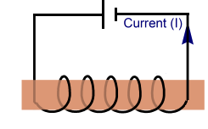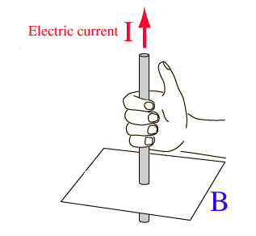i) ii)

11. a) What is Faraday’s Law of Electromagnetic Induction?

b) Indicate the direction of the induced current and the associated magnetic field generated in the coils shown

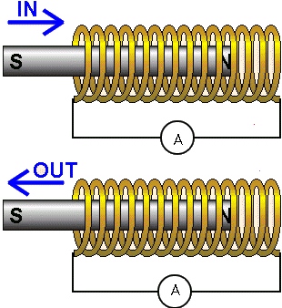 below:

**Sound and Waves**

12. a) What is the frequency of a sound wave that travels at 1.500 x 10 3 m/s in water with a wavelength of 145 cm?

b) What is the wavelength of the wave when it is transmitted into air at temperature of 15.0 ° C?

*ANS: a) 1.03 x 10 3 Hz b) 0.329 m*

13. A 16.0 m long string vibrates in a standing wave pattern such that 6 loops are produced.

a) Sketch the standing wave.

b) What is the wavelength of the wave?

c) If the frequency of vibration is 2.50 Hz, calculate the wave speed.

Answers: 1) a) 5.33 m b) 13.3 m/s